Predictive Analysis of Diamond Prices

Via Multi-Linear Regression

Joel Thomas (bs21dmu009)

|  |  |  |
| --- | --- | --- |
| Sr. No | Title | Page |
| 1.0 | Introduction | 3 |
| 2.0 | Descriptive Statistics | 5 |
| 3.0 | Exploratory Data Analysis | 6 |
| 3.1 | Visualization of Variables | 7 |
| 4.0 | Multi-Linear Regression Model | 17 |
| 4.1 | Multi-Linear Regression Statistics | 20 |
| 4.2 | Regression Coefficient Table & Analysis | 21 |
| 5.0 | Hypothesis Testing | 23 |
| 6.0 | Predictions | 24 |
| 7.0 | Conclusion | 25 |
| 8.0 | References | 26 |

**Introduction**

*Diamonds* are a rare, naturally occurring mineral composed of carbon. Each carbon atom in a diamond is surrounded by four other carbon atoms and connected to them by strong covalent bonds - the most vital type of chemical bond. This simple, uniform, tightly-bonded arrangement yields one of the most durable and versatile substances.

How are Diamonds Formed?

The saying, “Pressure makes Diamonds,” is more than a pop-culture idiom. Diamonds form at Extreme temperatures and pressures within the Earth’s mantle, about 100-150 miles below the surface. During volcanic eruptions in the mantle, the eruptions carve out pieces of mantle rock containing diamonds called xenoliths along the way and carry them to the surface. The diamonds within these xenoliths are extracted by mining them.

However, eruptions are not the only way diamonds are found on our planet; it is said that many asteroids that crashed into the Earth bore large reserves of diamonds in the rock.

**Process**

The purpose of this report is to investigate how the price of a diamond is affected by different variables and to produce a model that can predict the value of a diamond, with a high accuracy. Price is our target variable, while the other variables are the independent variables. The dataset consists of 53940 rows and 10 columns.

The accuracy of the model is determined by observing the R2value as well as ensuring the P-value of the variables in the regression is less than or equal to 0.05. The R2 value is a statistical measure in regression models that determines the degree of variability in the dependent variable that can be explained by an independent variable. In layman’s terms, the R2 value simply tells us how well the dataset fits the regression model

However, it’s important to keep in mind that the R2 value is not the only indicator of a good model and other factors must be reviewed and kept in mind while determining its accuracy.

The variables in the dataset are as follows:

* Carat: Weight of a diamond (Numeric)
* Cut: The symmetry, proportionality, and polish of the diamond (Categorical)
* Color: Color of the diamond (Categorical)
* Clarity: Refers to inclusions and blemishes that may appear in diamonds (Categorical)
* Depth: The depth of a diamond refers to its measurement from the table on top of the diamond to its cutlet at the base (Numeric)
* Table: The diamond’s table is a facet which can be seen when the stone is viewed face up. (Numeric)
* Price: Price of the diamond. (Numeric)
* X: Length of Diamond in mm. (Numeric)
* Y: Width of diamond in mm. (Numeric)
* Z: Height of diamond in mm. (Numeric)

The diagram below is a visual representation of the structure of a Diamond.

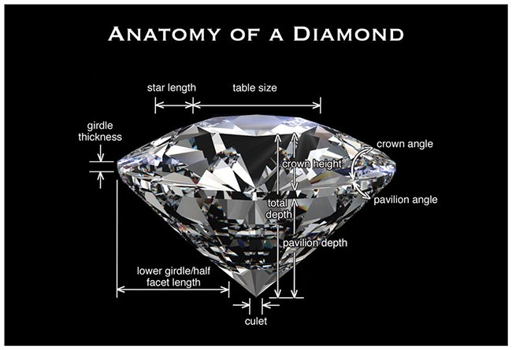

Figure 1: Structure of a Diamond

**Tools & Software used for this Report**

* SAS JMP PRO 16
* Python
* Microsoft Excel

**Descriptive Statistics**

The Categorical variables Cut, Color, Clarity have different values respectively and are as follows:

Cut: Ideal > Premium > Very Good > Good > Fair

Color: D > E > F > G > H > I > J

Clarity: IF > VVS1 > VVS2 > VS1 > VS2 > SI1 > SI2> I1

The Table below details the first 5 rows of the dataset:

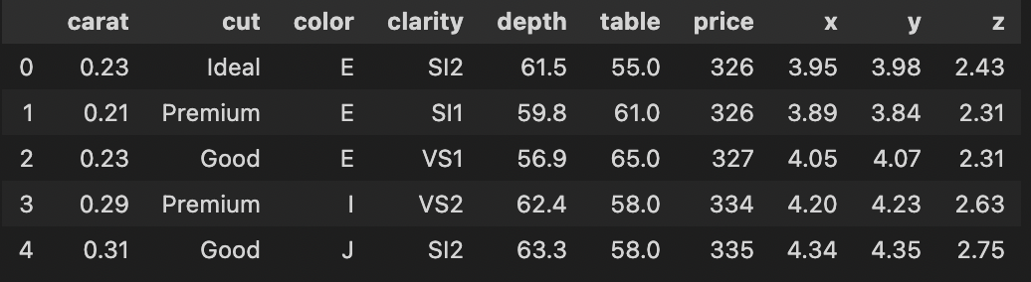

Figure 2: The first five rows of the dataset

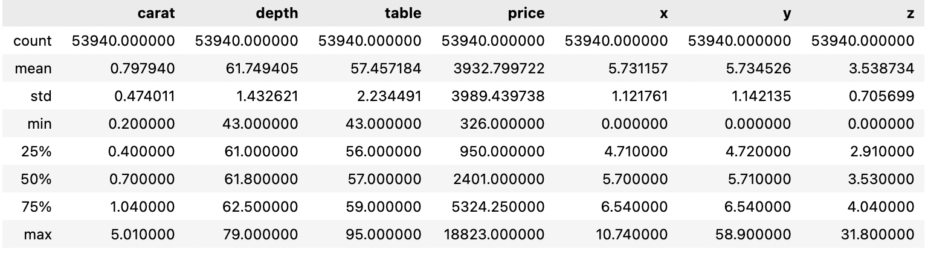

Figure 2.1: Data Stats of Numerical Variables

The table below details the descriptive statistics of each numerical independent variable, such as mean, standard deviation, the maximum and minimum value, and the quartile

However there lies an issue with the table above. If we carefully analyze the minimum values for X, Y, Z then we will see that each of those three columns have 0 as their minimum value, which is not possible because it doesn’t make sense to have either length, width, or height to be 0.

I clean the data and remove approximately 30-40 rows that contain the dimension 0 in either of the 3 columns X, Y, Z. Now let’s view the descriptive statistics of the variables.

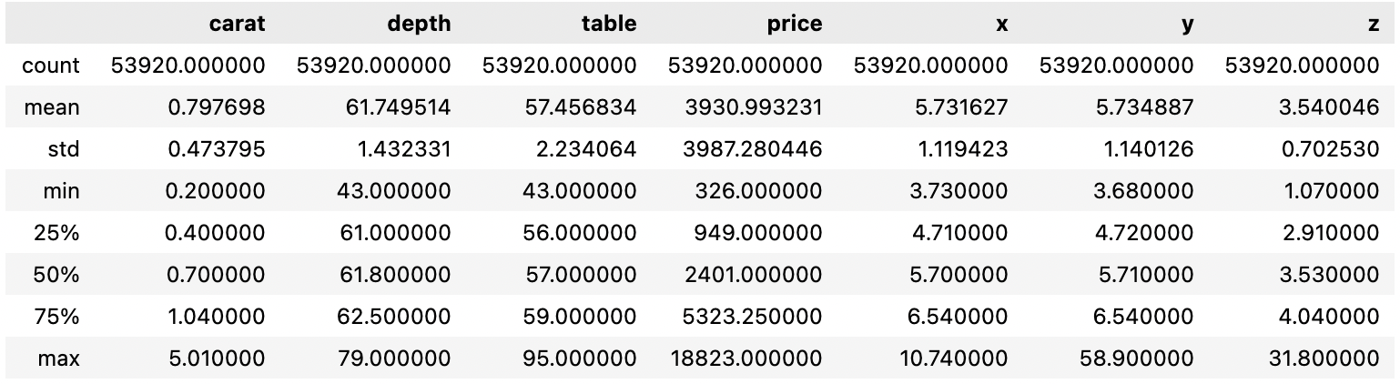

Figure 2.2: Cleaned Dataset Stats for Numerical variables

Now all the data has been thoroughly cleaned and we’re certain there are zero errors with our dataset and can move on with the data analysis.

**Exploratory Data Analysis**

Given that the purpose of this report is to investigate the effect of different variables on the dependent variable (Price), I have created various graphs that visualize the data and further our understanding of the dataset.

Correlation between Variables:

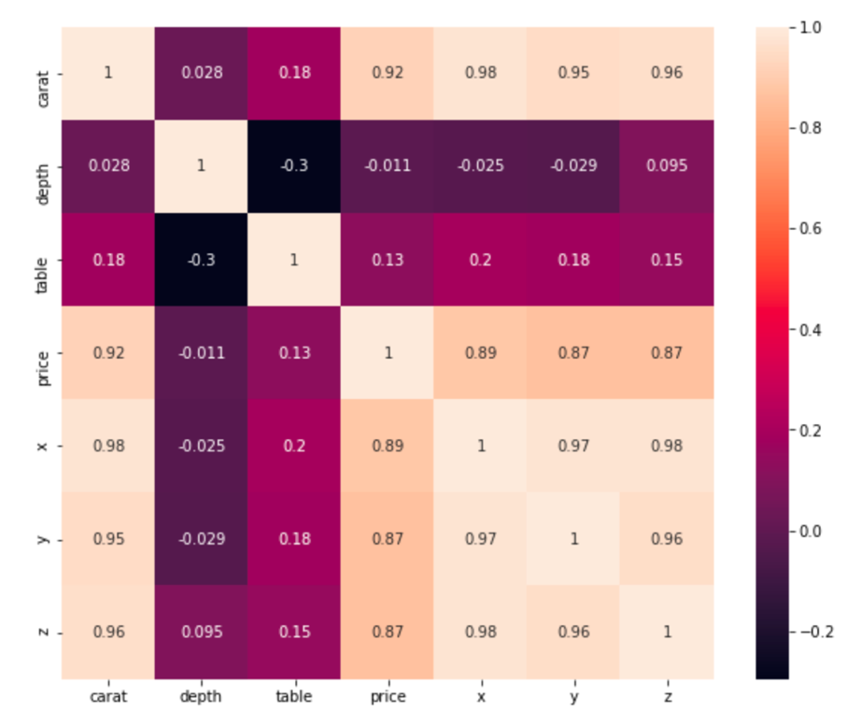

The diagram on the left is a heatmap of the correlation matrix between different variables in the dataset.

This heatmap tell us how strongly one variable affects another and is particularly useful in determining how strongly the independent variables influence the target variable (Price).

The vertical bar on the right is a key for the heatmap. The lighter the color of the block between two variables the stronger the correlation between them.

Figure 3: Heatmap of the Correlation Matrix

Conclusions:

1. Price of the diamond is highly correlated to Carat: The heavier/larger the diamond the rarer it is and so the more expensive it will be naturally.
2. Depth Is inversely proportional to Price: If the depth of a diamond is too great or too little, it will fail to reflect enough light to give it its glitter and shine.
3. Price is strongly correlated to the dimensions of the diamond (x, y, z).
4. Table has a weak/negligible influence on the price of a diamond.
5. X/Y/Z variables have a strong correlation with each other, which might suggest multicollinearity.

**Visualization of Variables**

**Carat**

Carat refers to the weight of the stone. Carat has the most significant impact on the price as the weight is proportional to the size of the diamond. As shown in the diagram below a 5.00ct diamond is far larger than a 1.00ct diamond.

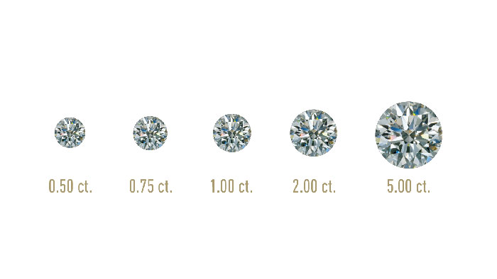

Figure 3.1.1: Range of Carats found in Diamonds

***Carat vs Price:***

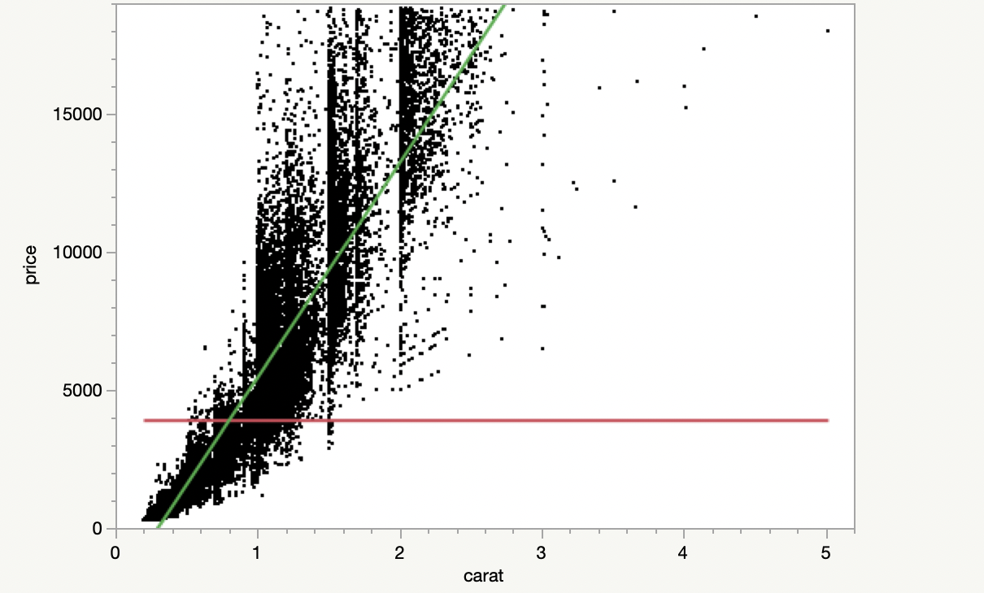

The scatter plot here shows an exponential relationship between price and carat. As mentioned before carat has the strongest impact on price compared to other variables.

This scatter plot verifies the correlation between price and carat.

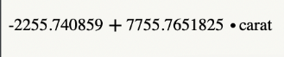

Figure 3.1.2: Scatter plot of Price against Carat

**Cut**

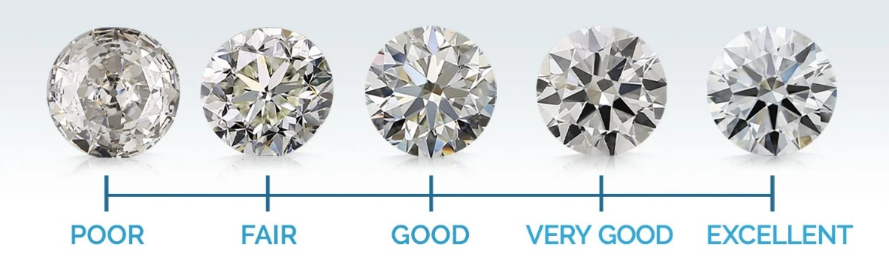

Figure 3.1.3: Range of Cuts found in Diamonds

Even though the carat of a diamond was determined to have the most decisive influence on price, the Cut of a diamond can still drastically increase or decrease its value.

The Cut of a diamond refers to its symmetry and proportionality, and the higher the cut quality, the more Diamond’s cost per carat increases. This is because more material needs to be removed to achieve those high-grade proportions and symmetry.

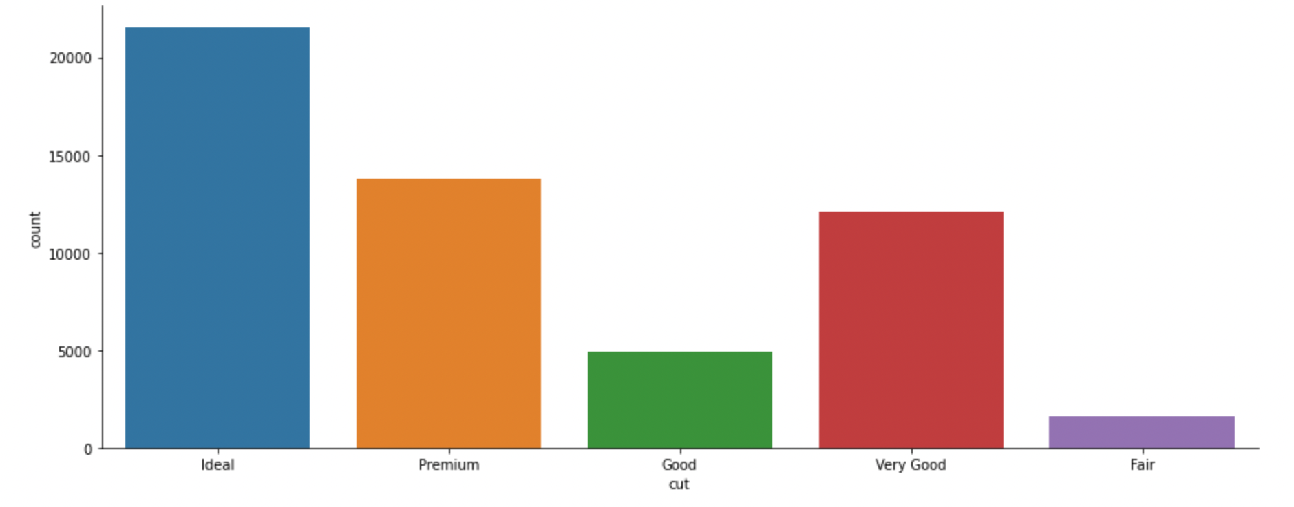

Figure 3.1.4: Count plot of the number of diamonds of varying Cuts.

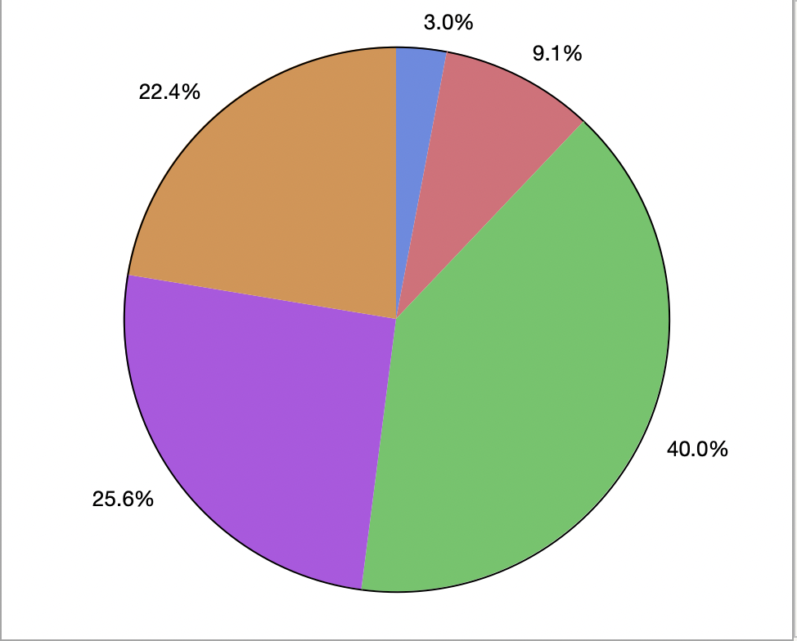

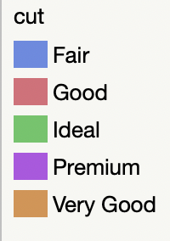

Figure 3.1.5: Pie Chart representing the population of each type of Cut

***Cut vs Price***

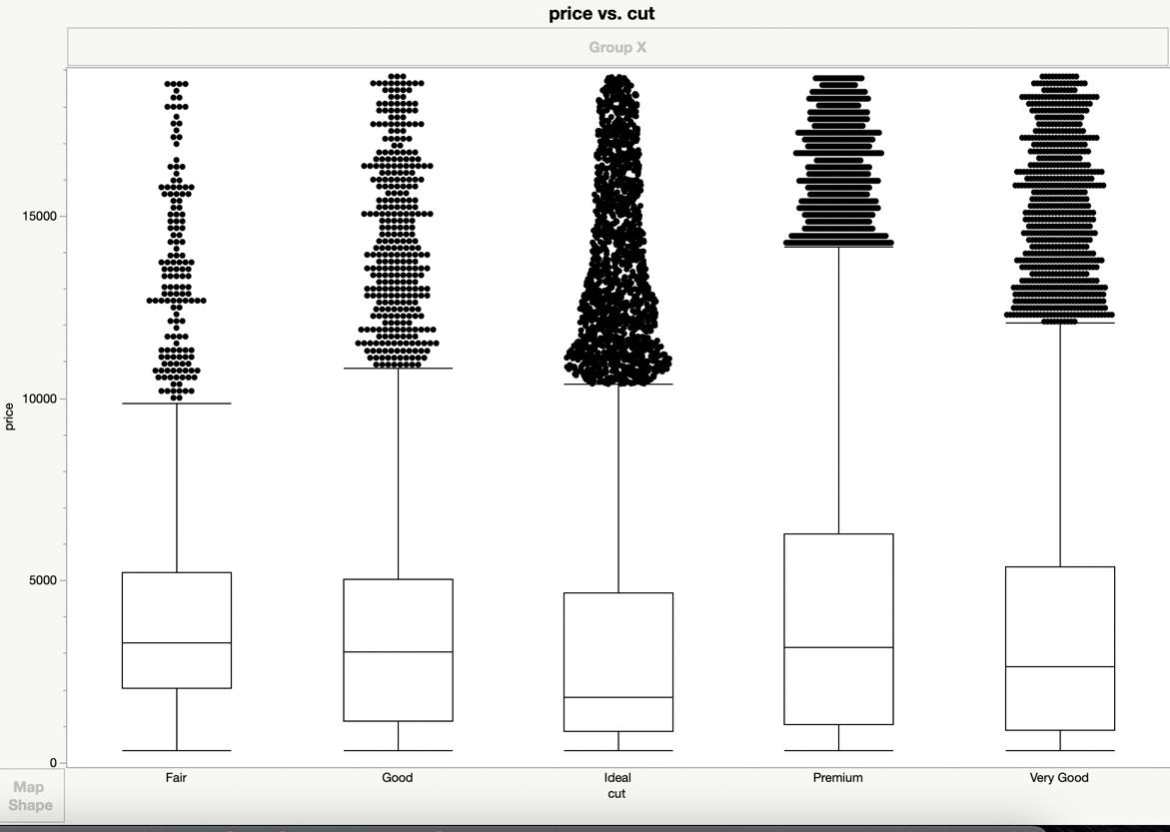

**Understanding Box Plots:**

The middle line in the box is the median/50 percentile

The lines on either side of the box represent the 25 & 75 percentiles.

The lines far outside the box represent the

25th percentile – 1.5*IQR

75th percentile – 1.5*IQR

*Any datapoint outside those lines are considered outliers

Figure 3.1.6: Box plot of Price against varying cuts of diamond

The box plot between Cut and Price tells us that diamonds with a premium cut are most expensive followed those with a Very good and Good Cut, etc.

**Color**

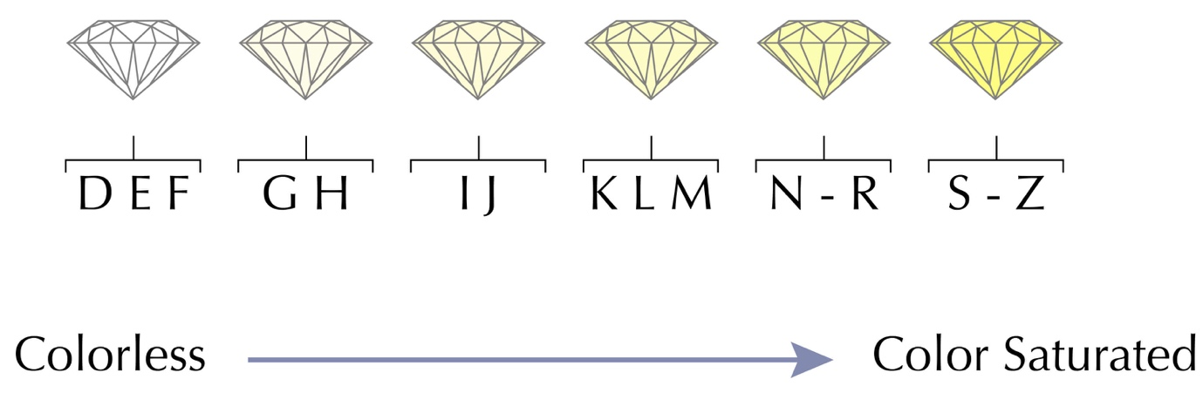 The colour of a diamond refers to its tone, saturation, and depth of colour. Diamonds do not always come in the sparkly blinding white tone. Instead, it can come in various colours ranging from colourless to a faint hint of brown. The colour has a decent influence on price as colourless diamonds are rarer and thus more valuable.

Figure 3.1.7: Range of Colours found in Diamonds

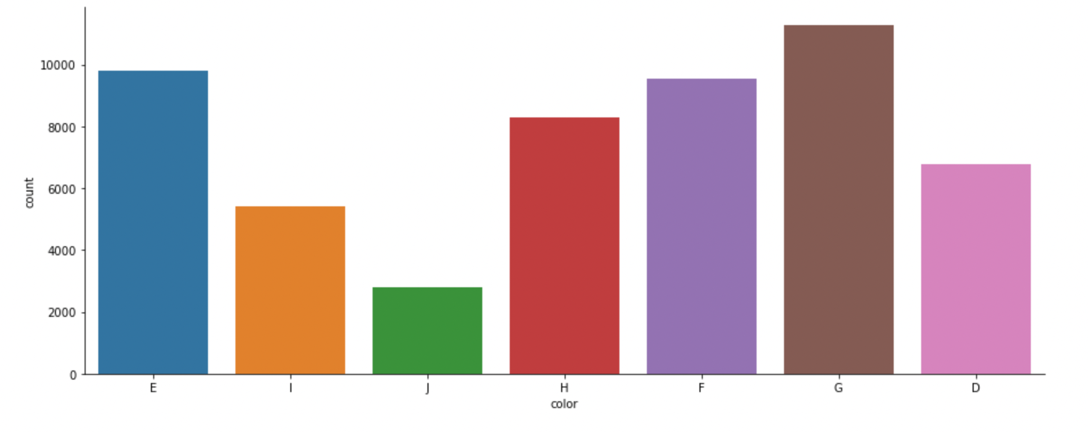

Figure 3.1.8: Count plot of diamonds of different Colors

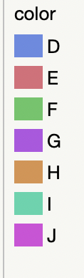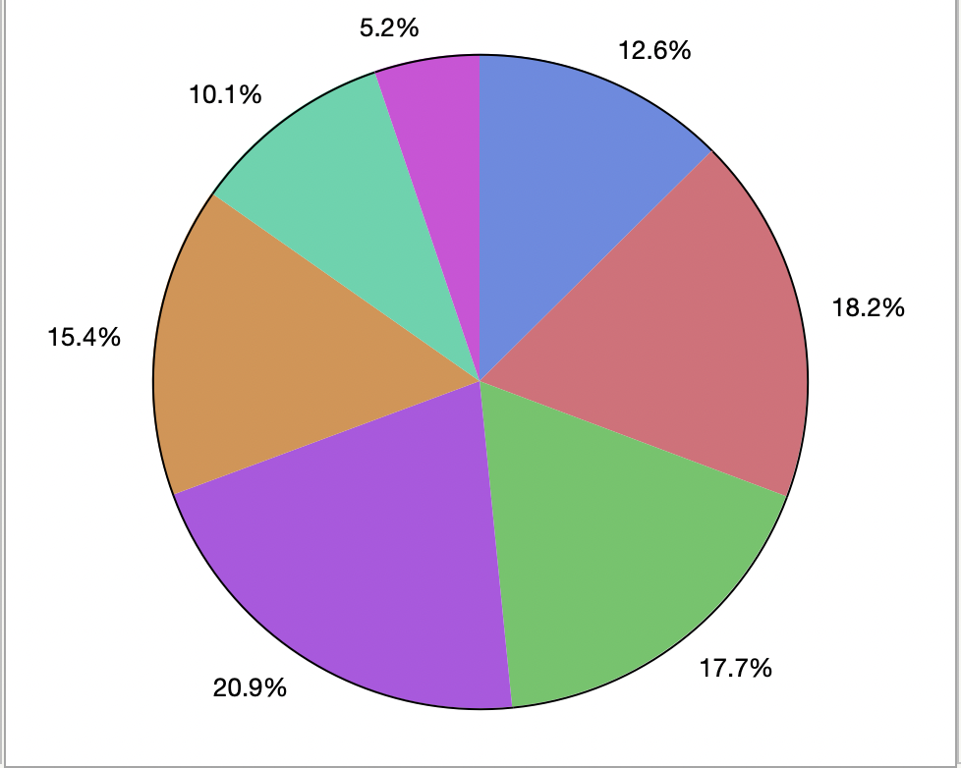

Figure 3.1.9: Pie Chart representing the population of each type of Colour

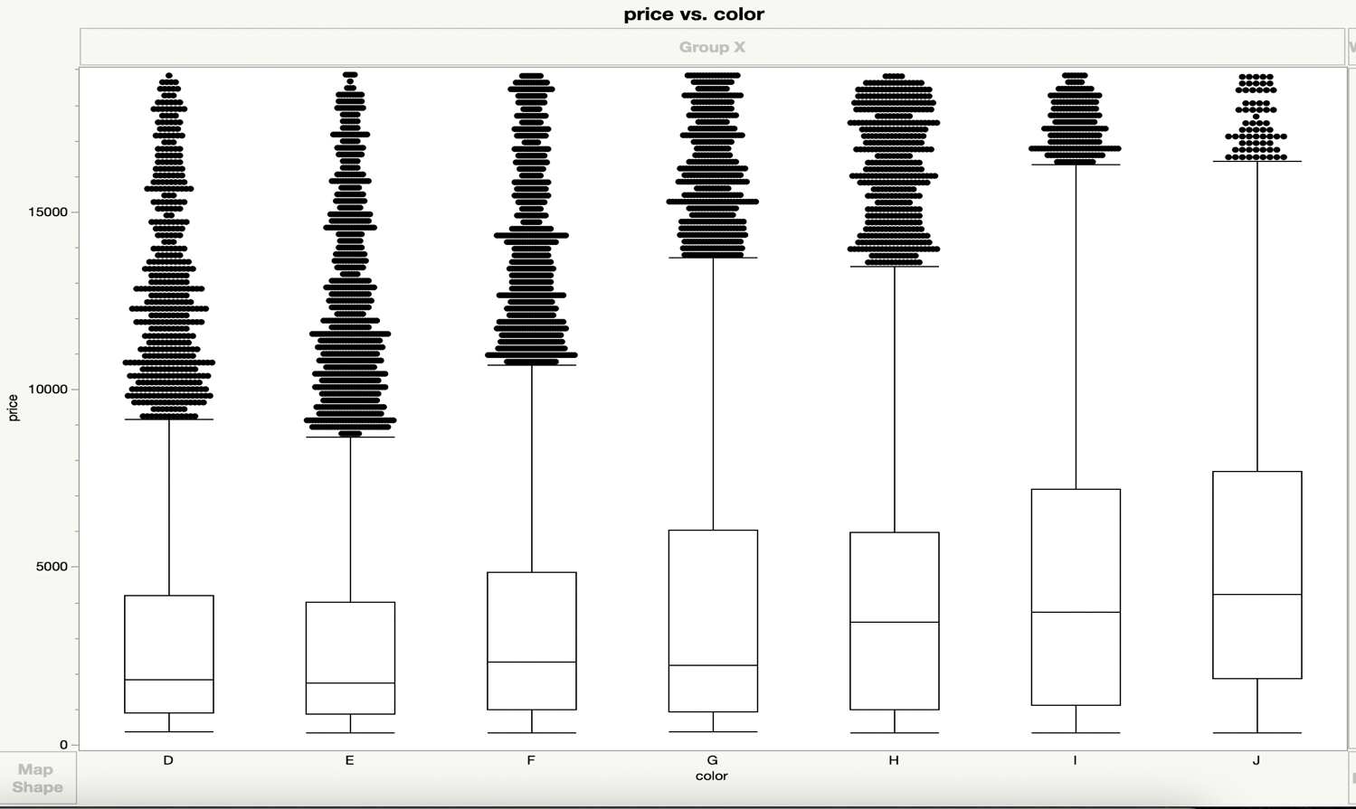***Color vs Price***

Figure 3.1.10: Box plot of Price against different colors of diamonds

**Clarity**

Clarity refers to the absence of inclusions and blemishes in each diamond.

Inclusions can mean anything ranging from tiny cracks or an imperfection regarding the symmetry of a diamond. It even refers to the possible presence of foreign particles within the diamond.

Blemishes refer to the changes brought upon a diamond during the cutting and polishing process. Extra polish lines or burns are examples of blemishes.

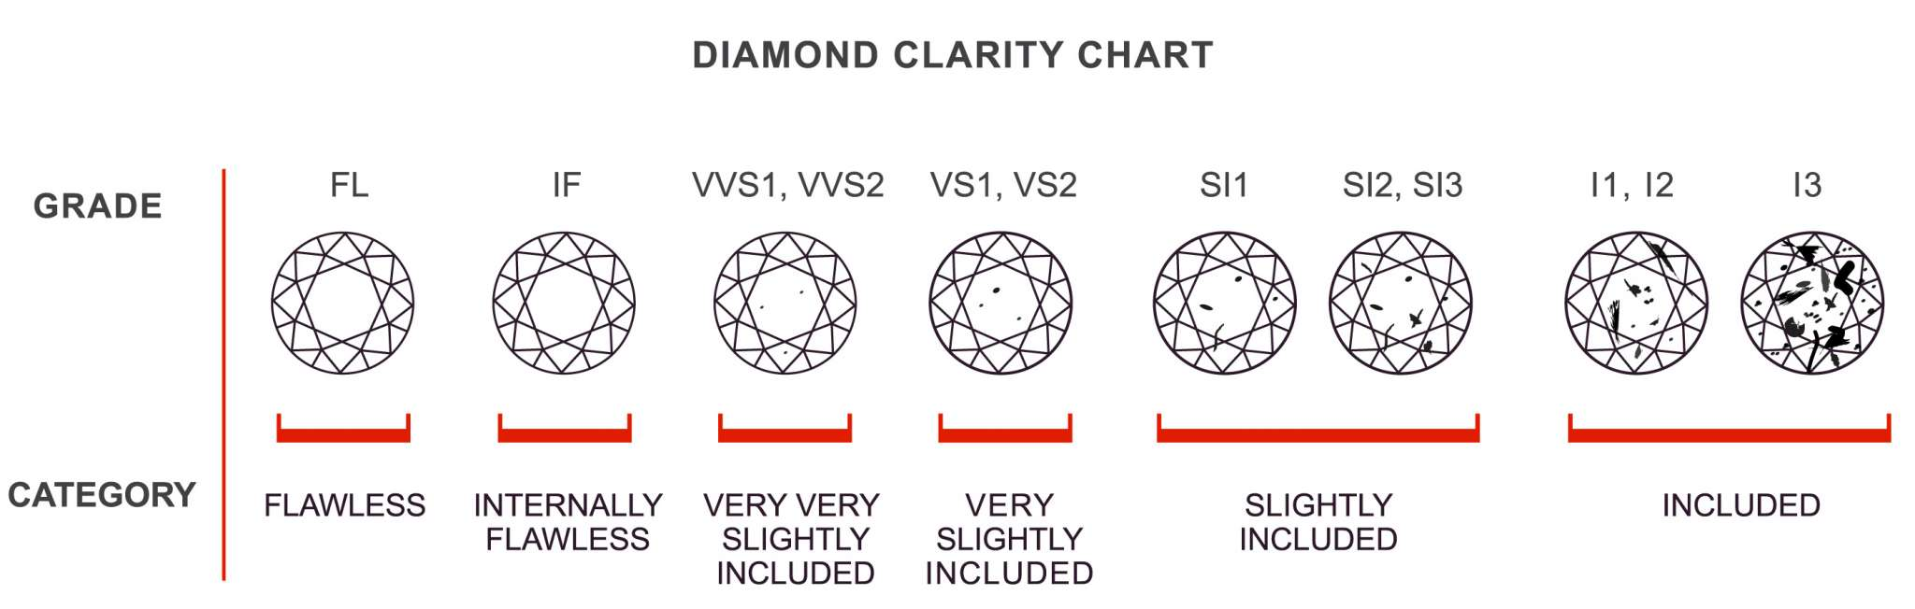

Figure 3.1.11: Types of Clarity found in Diamonds

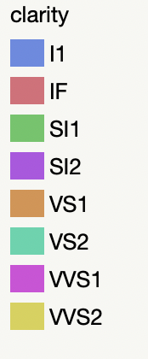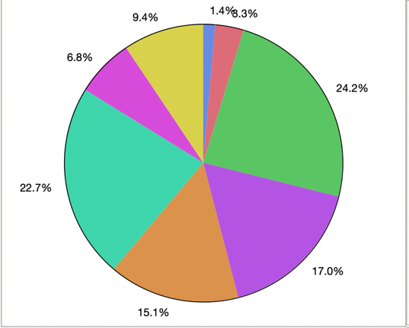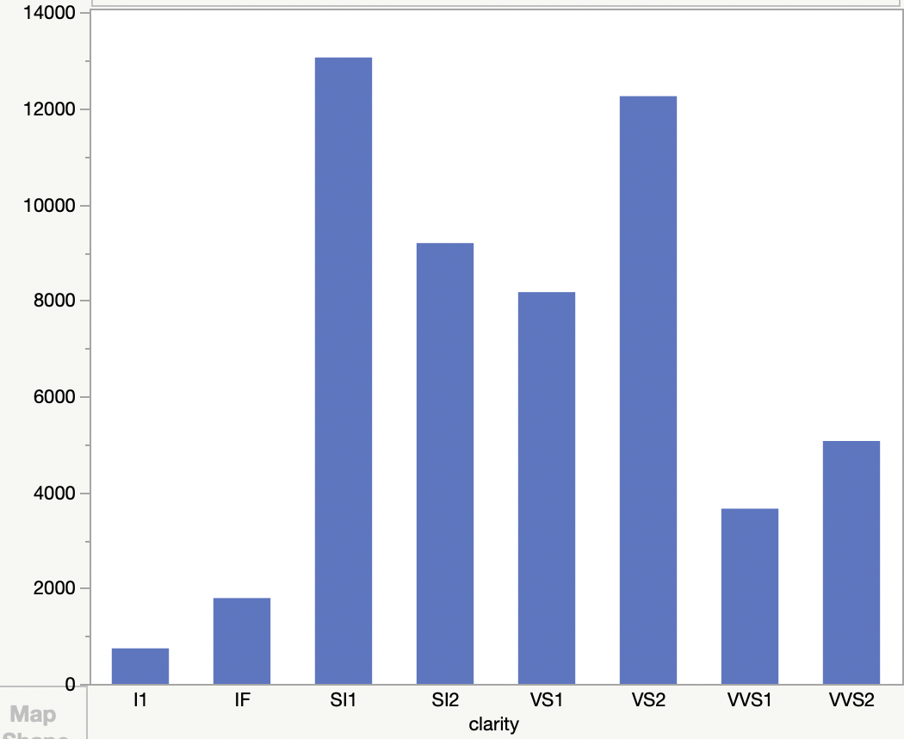

Figure 3.1.13: Pie Chart representing the population of each type of clarity

Figure 3.1.12: Count plot of varying types of Diamond Clarities

***Clarity vs Price***

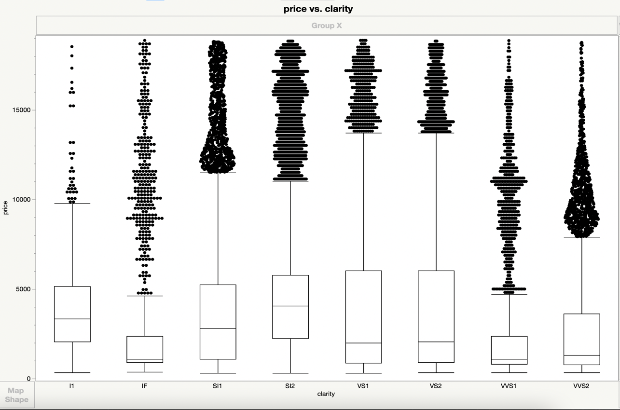

Figure 3.1.14: Box plot of Price against varying Clarity of diamonds

The box plot tells us that VS1 and VS2 are priced equally and have a higher cost margin compared to higher clarity grades like VVS1 or IF.

**Depth**

The depth of a diamond is its height measured from the cutlet to the table. Unlike other variables the depth of a diamond is best within a given range as too large or small of a depth will affect how much light is reflected by the diamond.

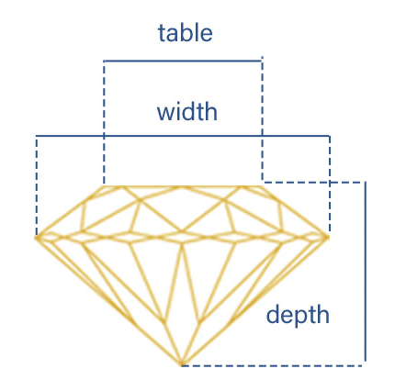

Figure 3.1.15: Visualization of the depth of a diamond

***Depth vs Price***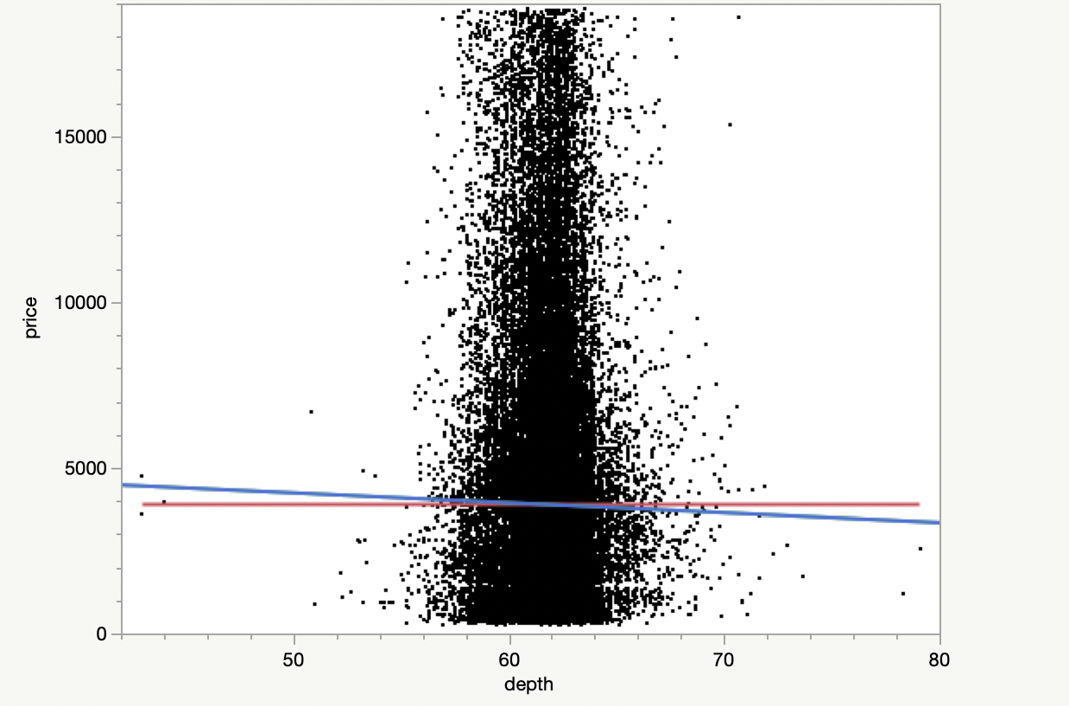

From this scatter plot of **Depth** against **Price** we see that there is no real relationship and price can vary greatly within a given depth range.

We also learned from the correlation heatmap earlier that depth and price has a negative relationship.



Figure 3.1.16: Scatter plot of Price against Depth

**Table**

The table on a diamond's surface is the large, flat surface facet seen when looking at the diamond from above. The size of the table is one of the most crucial aspects of a diamond's look. A big table not only lets light into the diamond but also disperses it across the other facets, creating a lovely glitter.

An excellent table must be balanced: it must be large enough to let plenty of light into the stone while not so enormous that it does not refract light onto the diamond's crown.

***Table vs Price***

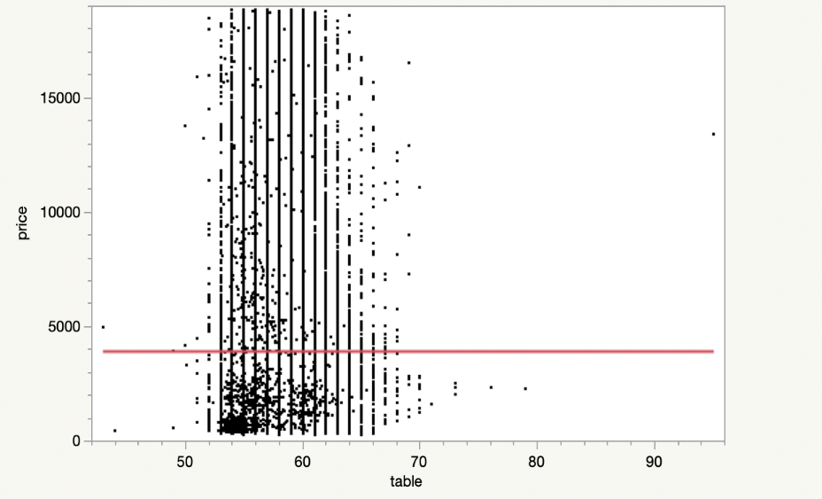

The scatter plot shows no real relationship between **table** and **price**.

This was expected given that the correlation heatmap depicted a weak correlation between table and price.

However, the scatterplot does confirm that the price varies within a given range of table.

Figure 3.1.17: Scatter plot of Table against Price

**X (Length)**

***X(length) vs Price***

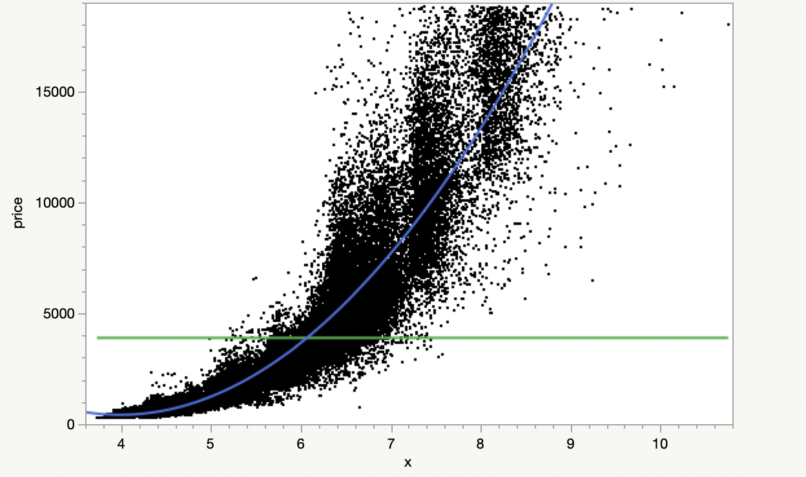

The scatter plot portrays a strong exponential relationship between **X** and **Price.**

This is in line with the strong correlation between the two variables on the heatmap.

Price=-14182.3 + 3160.2441*x

Figure 3.1.18: Scatter plot of X against Price

**Y (Width)**

***Y(Width) vs Price***

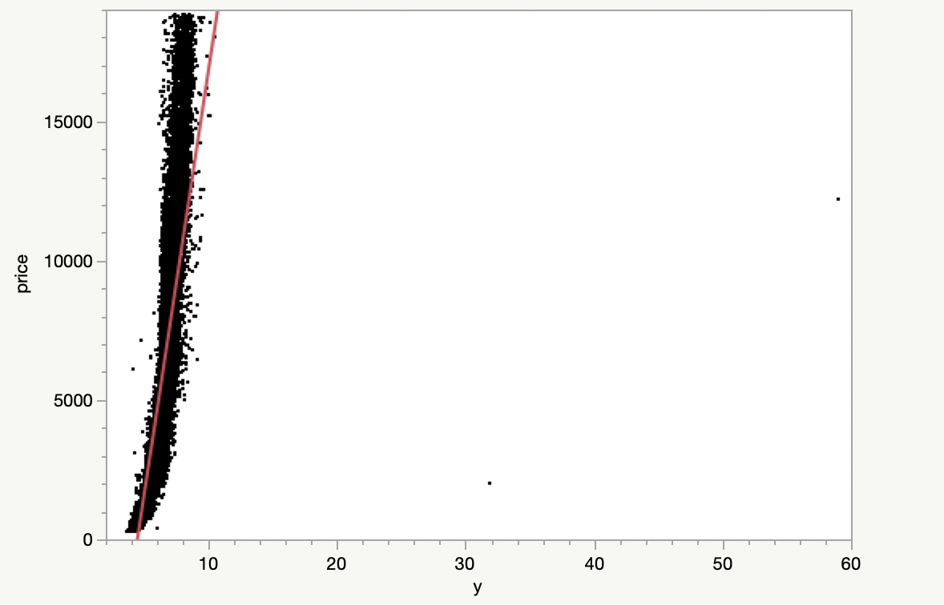

The scatter plot depicts an extremely steep curve, informing us of a strong possibly exponential relationship between **Width** and **Price**

This responds well to the correlation we saw between the two variables in the correlation m

Price=-13475.07 + 3035.126*y

Figure 3.1.19: Scatter plot of Y against Price

**Z (Height)**

***Z(Height) vs Price***

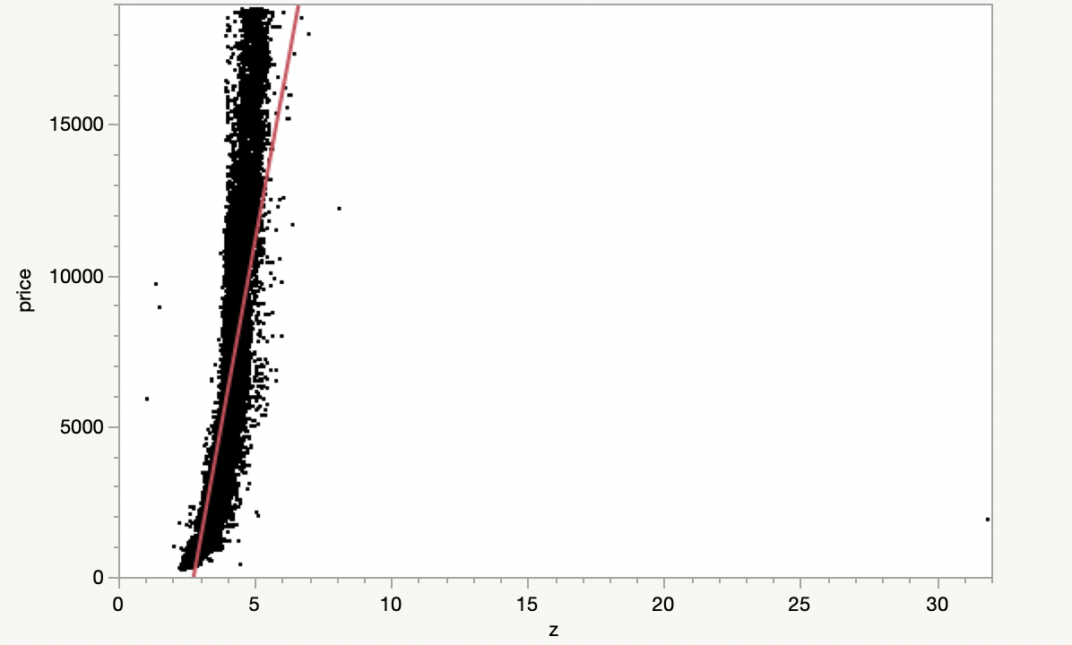

The scatter plot between **Z** and **Price** show a strong, possibly exponential, relationship between each other.

The plot shows a relationship very similar to that between **Y** and **Price,** this reinforces the possible idea of multicollinearity in the data.

Price=-13512.89 + 4927.5971*z

Figure 3.1.20: Scatter plot of Table against Price

**Multi-Linear Regression Model**

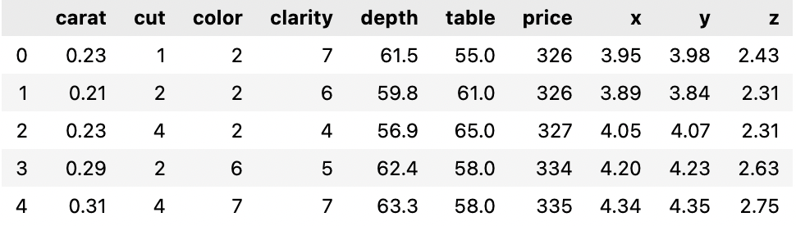Regression is a statistical method for determining the relationship between two or more economic variables. The first phase is calculating the independent variable's coefficient and then determining the reliability of the calculated coefficient. The diamond price prediction model is built with the variables Price(Y) and Xi = (Carat, Cut, Clarity, Color, x, y, z, Depth, Table)

Figure 4.0.1: Descriptive stats with encoded categorical data

Prior to building the model, the dataset needed to be remodeled so it can be used for regression. First the categorical data needed to be dealt with. The categorical variables (Cut, Color, Clarity) were given dummy values to replace with, and so the final dataset is as follows:

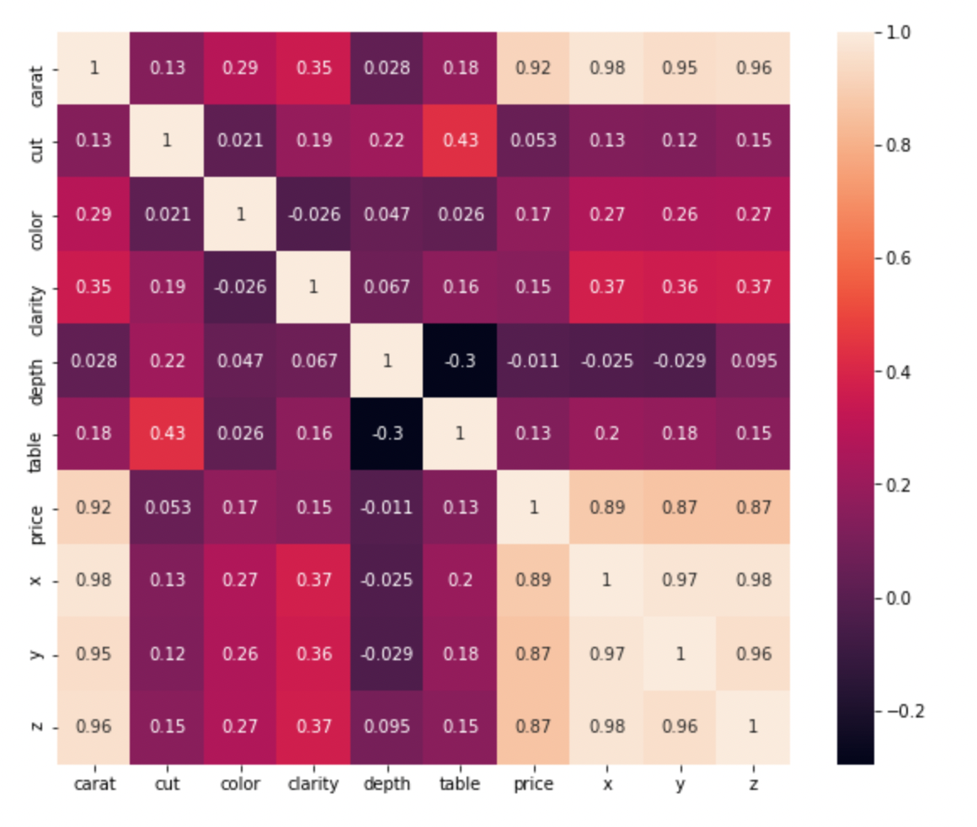

This is a heatmap of the correlation matrix between the variables after the categorical values were converted into numerical ones.

Figure 4.0.2: Correlation Matrix including categorical data

**Conclusions**

In this heatmap we have three new variables, Cut, Colour and Clarity. The map clearly describes the relationship between the three variables and price; each having a very weak correlation with price.

**\*Since the categorical data have been ranked on a scale of 1 to 7 or depending on the number of different values in a given variable, there exists a certain limitation that is, higher ranked values could possibly have more “weightage” in the algorithm, potentially affecting results. Due to SAS JMPs’ lack of label encoding features, this is the most optimal option.**

*Multi-linear Regression equation*:

Ŷ = β0 + β1 X1 + β2 X2 + β3 X3+ β4 X4 + β5 X5 + + β6 X6+ β7 X7 + β8 X8 + β9 X9

Where,

Ŷ is the predicted value of dependent variable Y.

Xi is the actual value of independent/explanatory variable:

X1: Carat

X2: Cut

X3: Colour

X4: Clarity

X5: Depth

X6: Table

X7: x

X8: y

X9: z

βi is the regression coefficient of respective Xi., where i=1,2,...9

Now I will be detailing the conditions and values we try to find from our model.

***Method of Regression: Ordinary Least Squares***

Ordinary least square method is designed to fit a line through a scatter of points is such a way that the sum of the squared deviations of the points from the line is minimized.

***Co-efficient of Determination (R2)***

Co-efficient of determination is a measure which indicates the percentage of the variation in the dependent variable is due to the variations in the independent variables. R2 is a measure of the accuracy of the model.

R2 = 1- SSResid / SSTotal

SSResid = Σ(Y - Ŷ)2

SSTotal= Σ(Y - Y̅)2

Y̅ = Mean of Y variable

***Total Sum of Squares (TSS)***

Sum of the squared deviations of the sample values of Y from the mean of Y.

TSS = SUM ( Yi − Y)2

Yi = dependent variables

Y = mean of dependent variables

i = number of observations

**Multi-Linear Regression Statistics**

The model was constructed and run through on SAS-JMP and below are the summary statistics of the model

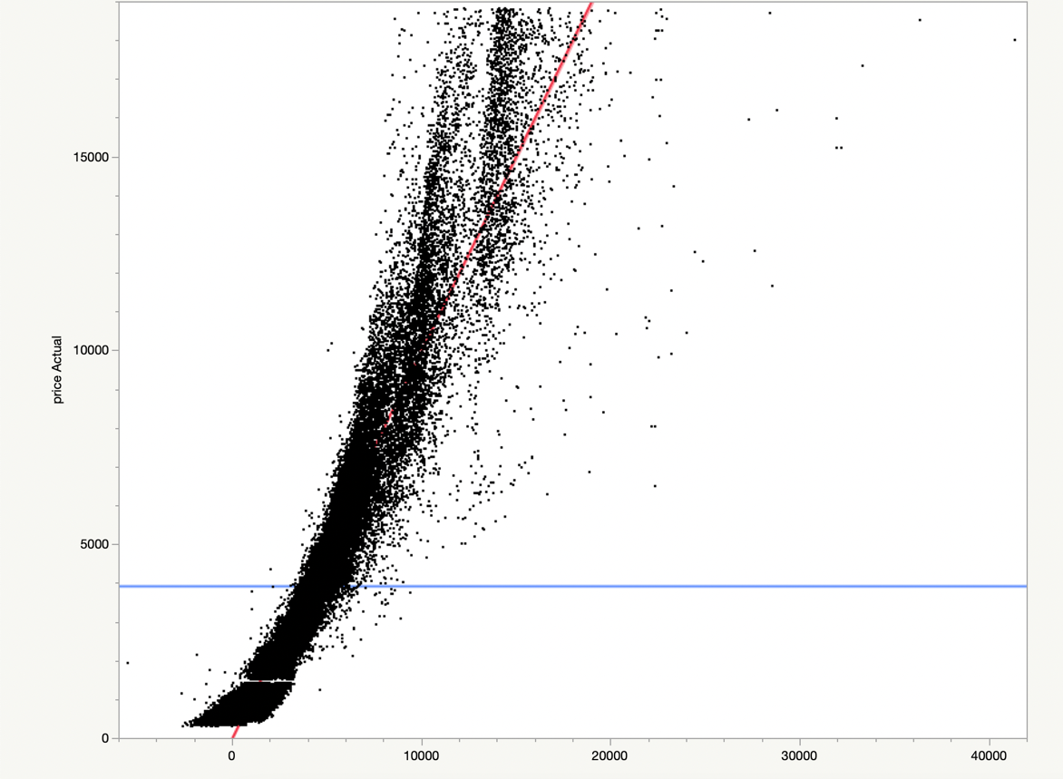

Figure 4.1: Actual Price vs Predicted Price Scatter Plot

Adjusted R2 – A corrected goodness of fit measure for linear models. It identifies the percentage of variance in the target variable.

RSME- A measure of how spread-out residuals are. It tells us how concentrated the data is around the line of best fit.

Observation- Total number of observations

|  |  |
| --- | --- |
| Summary of Fit | |
| R2 | 0.907187 |
| R2 Adjusted | 0.907171 |
| Root Mean Square Error | 1214.848 |
| Mean of Response | 3931.022 |
| Observations | 53919 |

**Regression Coefficient Table & Analysis**

The following table depicts the regression statistics:

Estimate :

Coefficient of the Variable

Standard Error : Standard deviation of the error

*The lower the P-Value, the stronger the significance of the variable on the target variable.

P<= 0.05 is the optimal value.

|  |  |  |  |  |
| --- | --- | --- | --- | --- |
| Term | Estimate | Std.Error | t-Ratio | Prob>|t| |
| Intercept | 10909.482 | 414.9951 | 26.29 | <.0001 |
| Carat | 10948.942 | 55.0332 | 198.95 | <.0001 |
| Cut | -120.1788 | 5.7077372 | -21.06 | <.0001 |
| Color | -323.2353 | 3.255475 | -99.29 | <.0001 |
| Clarity | -499.5253 | 3.523185 | -141.8 | <.0001 |
| Depth | -79.27753 | 4.911096 | -16.14 | <.0001 |
| Table | -26.77445 | 2.944586 | -9.09 | <.0001 |
| X | -936.547 | 37.4887 | -24.98 | <.0001 |
| Y | 59.805085 | 20.89473 | 2.86 | 0.0042 |
| Z | -104.0305 | 40.74876 | -2.55 | 0.0107 |

**Regression Equation**

**Ŷ = 10909.48 +109489.94X1 -120.18 X2 -323.23 X3 – 499.52 X4 – 79.28X5 – 26.77X6 -936.55X7 + 59.81X8 -104.03X9**

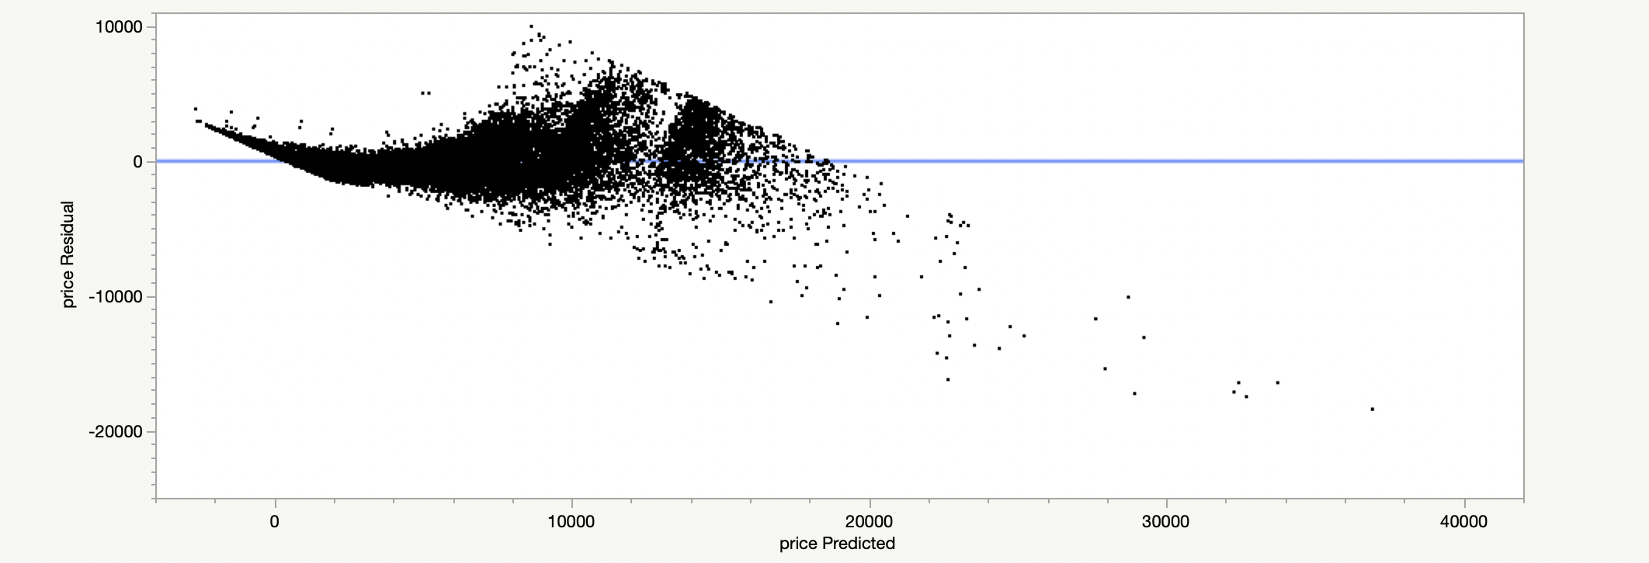**Residual Plot**

**Regression Analysis & Remarks**

1. The model achieved an R2  value of 0.907, which can be translated to 91% accuracy, implying that the independent variables of our model can explain 91% of the variance of the dependent variable (Price).
2. Concerning the correlation matrix, we saw that Price shared a strong correlation with Carat/X/Y/Z variables and a weak correlation with Depth/Table/Cut/Clarity/Color.
3. However, the regression prediction equation shows that only Carat and Y have a positive β value, while the rest of the variables have a negative β value. This contradicts the results we saw in the correlation matrix, and this phenomenon can be explained by some possible factors/hypotheses:

* The correlation coefficient reflects the strength of the linear link, but the slope coefficient does not.
* The slope interpretation shows how much the response changes when the predictor is increased by one unit. This type of interpretation is not possible with correlation.
* The large intercept value β¬¬0 (10909) could potentially act as a buffer for the negative β values in the equation, as it is far larger than any of the other β values, e.g.
* (β2 = -120.18, β3 = -323.23).
* The influence of the other variables on a given variable cannot be denied as a β value is a change in Price while keeping other factors constant.

1. In addition, we observe that the p-values for each variable are below 0.05, which means that each variable is statistically significant to the target variable. Hence, we are not required to eliminate any variables from our regression regardless of whether they had a weak/strong correlation with Price.

The regression model was run without the Y and Z variables to rule out the possibility of multicollinearity in the dataset. The shift in p-values between the variables further reinforced the possibility of multicollinearity.

However, removing both variables did not improve accuracy, and the p-values were not high enough to justify removing the two variables from the column; hence we resort to the initial model.

**Hypothesis Testing: - Model Utility Test**

In this section we’re keen to know if the dependant and independent variables share a relationship with one another. The Null and Alternate hypothesis are as follows:

Hypothesis -

H0 : β1 = β2 = β3 = β4 = β5 = 0

There is no linear relationship between the dependent and independent variables.

HA : βj ≠ 0 where j = 1,2,3,4,5

There is at least one independent variable which has a linear relationship with dependent variable.

ANOVA :

With significance α = 0.05, (k=Number of coefficients, N= Number of observations)

|  |  |  |  |  |
| --- | --- | --- | --- | --- |
| Analysis of Variance | | | | |
| Source | Degrees of Freedom | Sum of Squares | Mean Square | F-score |
| Treatment | k-1 | SST | MS­T = SST / k-1 | F = MST / MSE |
| Error | N-k | SSE | MS­E = SSE / N-k |
| Total | N-1 |  |  |

**\*Note*:**

The value “e” refers to 10x.

“e+10” = 1010

|  |  |  |  |  |  |
| --- | --- | --- | --- | --- | --- |
|  | Degrees of Freedom | Sum of Squared | Mean Squares | F | Prob > F  (p-value) |
| Regression | 9 | 7.7766e+11 | 8.641e+10 | 58549.09 | <.0001 |
| Residual | 53909 | 7.9562e+10 | 1475855.4 |
| Total | 53918 | 8.5722e+11 |  |

If **F – Statistic value > F – Critical value**, the null hypothesis can be rejected.

The table data show that our F – Statistic value is 58549, however determining our F – Critical value is problematic due to the huge degree of freedom for the denominator is 53909.

So, instead we can use the model's P-value, which is less than 0.0001, which is considerably below the 0.05 criterion, hence we can reject our null hypothesis and conclude that our model has at least one independent variable that has a linear relationship with the dependent variable.

**Predictions**

Below is a table of random rows of values from the dataset comparing values of price predicted using the multi-linear regression model alongside the residual price:

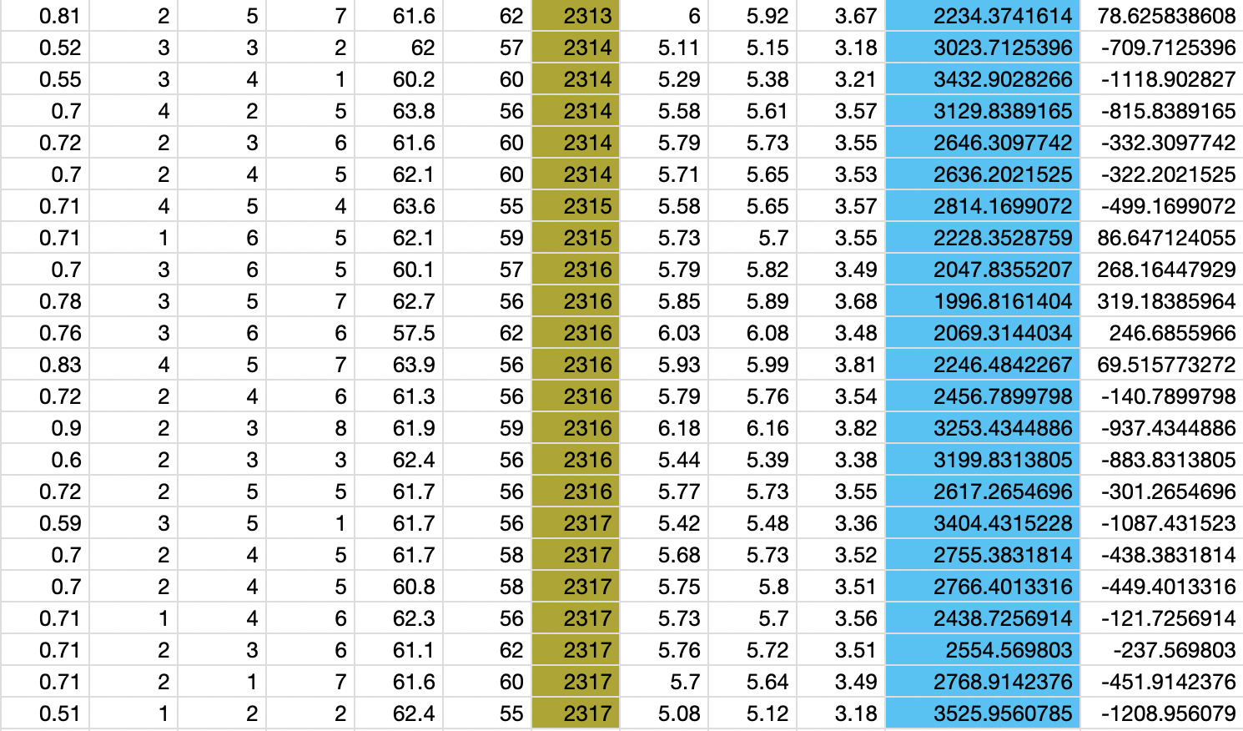

**Conclusion**

We looked at the numerous factors that might influence a diamond's Price and their relation to pricing. Like carat and Price, some factors showed predicted associations with their exponential relationship. Some partnerships, on the other hand, diverged from our expectations. For example, we discovered that depth and table had no meaningful link with Price but that a particular price could only be obtained inside a specific range of depth and table values, not outside of it.

Our visualizations of categorical data, such as Clarity vs Price, uncovered surprising tendencies: specific lesser clarity diamonds had larger cost margins than better clarity diamonds.

We witnessed a strong correlation between Price and factors like Carat, X/Y/Z, and a poor correlation with Color, Cut, and Clarity when we analyzed the correlation matrix. Though little evidence of multicollinearity was found through observations of minor shifts in p-values when removing X/Y/Z variables one by one in the correlation matrix, it was deemed unnecessary to omit the columns because they did not affect the model's accuracy or improve the p-values of other independent variables and removal would only result in loss of information.

Although the multi-linear regression model obtained a 91% accuracy rate, it does have one flaw: owing to the categorical encoding approach used, a weightage/priority relation issue depends on how highly ranked the categorical value is in a specific row. This may have some impact on the model's prediction power, but given the precision of our model, we can presume that the impact is not significant. However, improved category encoding approaches have the potential to improve accuracy.

We cannot depend on the F Ratio alone to make conclusions regarding our null hypothesis in the model utility test. The number of parameters in the model and the number of observations in our data set can impact the magnitude of the F Ratio.

P-values show how strong the evidence is against our null hypothesis, and we used them to reject the null hypothesis in our model utility test.

To summarize this report, the model can effectively forecast the price of a diamond with a 91 percent accuracy and little multicollinearity across variables.

**References**

Dataset Source:

[Diamonds | Kaggle](https://www.kaggle.com/datasets/shivam2503/diamonds)

Theory/Info:

[Diamond Colour Chart & Understanding “Colourless” | The Diamond Pro (diamonds.pro)](https://www.diamonds.pro/education/color/)

[Ideal Diamond Depth and Table by Cut | The Diamond Pro (diamonds.pro)](https://www.diamonds.pro/education/diamond-depth-and-table/)

[Diamond Clarity: Understanding Diamond Clarity Charts and Buying Guide (diamonds.pro)](https://www.diamonds.pro/education/clarity/)

[Diamond Cut As The Most Important of the 4 Cs | The Diamond Pro (diamonds.pro)](https://www.diamonds.pro/education/cuts/#:~:text=Cut%20refers%20to%20the%20facets,and%20fire%20of%20the%20diamond.)

[Multiple Linear Regression | Introduction to Statistics | JMP](https://www.jmp.com/en_in/statistics-knowledge-portal/what-is-multiple-regression.html#:~:text=Multiple%20linear%20regression%20is%20used,of%20one%20continuous%20predictor%20variable.)